Completing Cases Worksheet (Closed Case Auditor)

Admin Worksheet View

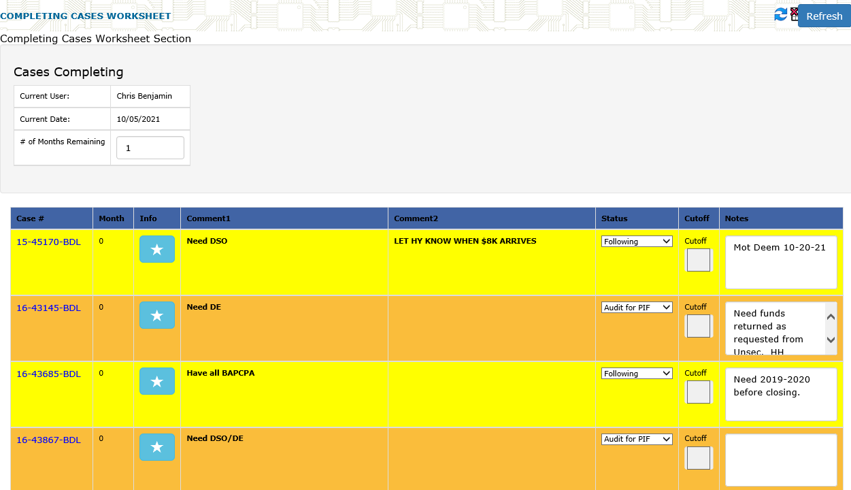

Info Modal View (Pulls info from worksheet for quick BAPCPA data)

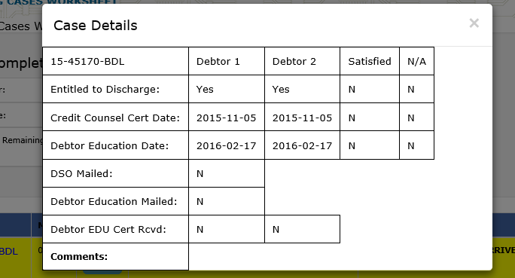

Cases marked Ready for Cutoff status and checkbox (only enabled when status is Ready for Cutoff) then those drop to the bottom in a new section. There is a print that prints a report that contains these cases so they can use it for verifying refunds after cutoff.

